Common Trust Policy, Use as Published
Aquila Mental Health and Wellbeing Policy

Reviewed January 2025
Date of next Review: January 2028

Aims/Purpose:
This policy outlines the ethos of the Aquila MAT regarding mental health and emotional well-being, and it summarises the preventative measures each school undertakes. The policy also aims to give all staff clear guidance as to which steps to take in the event of a child or young person developing a mental health difficulty.
This policy also reflects statutory guidance ‘Keeping Children Safe In Education’ 2024 (KCSIE)

Safeguarding and promoting the welfare of children and young people, including their mental health, is everyone’s responsibility. Aquila Schools are committed to safeguarding and promoting the welfare of children and young people and we expect all Trustees, Governors, staff and volunteers to share this commitment.

Policy Statement
According to the World Health Organisation:

Mental health is a state of wellbeing in which every individual realises his or her own potential, can cope with the normal stresses of life, can work productively and fruitfully, and is able to make a contribution to her or his community. Mental health is fundamental to our collective and individual ability as humans to think, emote, interact with each other, earn a living and enjoy life. On this basis, the promotion, protection and restoration of mental health can be regarded as a vital concern of individuals, communities and societies throughout the world.

At Aquila Multi Academy Trust, we are committed to the protection and promotion of positive mental health for all students and staff. We will continuously endeavour to improve the mental health of the school community by utilising a whole school approach to mental health, and via the identification and implementation of positive processes and practices which promote good mental health and wellbeing.
In addition to promoting positive mental health, we recognise that one in six children and young people and one in six adults may meet the criteria for a diagnosable mental health problem, with emerging evidence of a recent rise in anxiety and depression in some groups (as of 2020). We aim to identify and provide timely and appropriate support for all members of the school community affected both directly and indirectly by mental health problems.

Policy Aims and Objectives

By developing and implementing practical, effective and positive policies and procedures relevant to our schools and developed in conjunction with students and their parents and carers, we can promote a safe and supportive environment and ethos which is conducive to the mental health and wellbeing of the whole school community.
We will:
- Support students to understand their emotions
- Help children to manage change and adversity and develop resilience
- Provide an environment which is conducive to students sharing concerns about themselves or others
- We will promote a mentally healthy school environment by:
- Adopting a whole school approach to mental health and wellbeing
- Raising awareness in the whole school community of the signs and symptoms of mental health problems
- Supporting staff to manage their own mental health and wellbeing
- Supporting staff to respond swiftly and effectively to any signs of an emerging mental health problem
- Engaging in activities which promote mental health and wellbeing and a sense of belonging in the whole school community
- Celebrating individual differences in students, ensuring all students feel valued and respected
- Valuing and celebrating non-academic achievements

The Mental Health and Wellbeing Policy has the following objectives. To;
- Ensure all schools in the Aquila trust have identified their key staff needed to support children and to help all staff understand their role
- Raise awareness of good mental health and its impact on learning and behaviour
- Support staff in promoting good mental health to children, parents and carers
- Support staff in identifying those that could be at risk and taking the right action
- Support staff in working collaboratively to support children with mental health needs
- Signpost staff to organisations that can support children and/or their families.
- Support children at risk of non-attendance through poor mental health.
- Outline immediate steps to be taken when there are high levels of risk
- Provide opportunities for staff and students to look after their mental wellbeing.
- Promote positive mental health in all staff and students
- Reduce discrimination and stigma by increasing awareness and understanding of mental health problems
- Increase awareness of early warning signs of mental health problems

This policy applies to all members of the school community, Pupil, Staff, Governors and Trustees.

Policy Values

Mental Health can affect everyone
Mental Health can affect all of us. How we think and feel about ourselves and our lives impacts on our behaviour and how we cope in tough times. It affects our ability to make the most of the opportunities that come our way and play a full part amongst our family, school, workplace, community and friends. It is also closely linked with our physical health. Whether it is called well-being, emotional welfare or mental health, it is key to living a fulfilling life.

Every Child Matters
The mental health and wellbeing policy is a whole-school policy. Resources will be made available to every school within the Aquila Trust to ensure we promote well-being, monitor the child’s needs and respond accordingly.

Healthy Bodies and Healthy Minds
Research has shown that good physical health can lead to good mental health. Schools in the Aquila trust will promote both of these aspects given they will both impact on achievement and learning.

The Aquila values of collaborate, enrich, trust, innovate, aspire and nurture aim to promote positive mental health and wellbeing in pupils and staff so that ‘They will soar on wings like eagles.’ Isaiah 40:31

This set of values is reflected in all our policies.
Joy Hope Forgiveness Love Resilience
Our school offers a supportive, inclusive, nurturing and inspiring learning environment where each member is known by God, loved and empowered to reach their full potential. Children are encouraged through an aspirational and engaging curriculum to develop their knowledge, skills and character so that they can truly flourish, both now and into the future.

Lead Members of Staff
Whilst all staff have a responsibility to promote the mental health of students, staff with a specific, relevant remit include:
Aquila Trust Leads:
Aquila has the following trust-wide appointments who can be contacted for advice:

Claire Beyzade: Senior Mental Health Lead
Aquila Educational Psychologist
Isabelle Bowey: Assistant Educational Psychologist
Teresa Grimwood: Lead SENCo
Annie Wiles: Trust Safeguarding Lead

School Leads
- Louise Buckland -Senior mental health lead
- Sarah Mountjoy - Designated safeguarding lead
- Michelle Kiting - Designated Governor for Mental Health and Wellbeing
- Ashten Blades - Head of PSHE/ RSE
- Sarah Graham - First Aid Leaders

Any member of staff who is concerned about the mental health or wellbeing of a student should speak to the mental health lead in the first instance.
In the event of any concerns that a student may be at risk of immediate harm, the school’s child protection procedures should be followed, with an immediate referral to the designated safeguarding lead.
If the student presents as a medical emergency, then the school’s procedures for medical emergencies should be followed, including the involvement of first aid staff and contacting the emergency services.
Where a referral to Children and Young Peoples Mental Health Services (CYPMHS, previously known as CAMHS) is appropriate, this will be led and managed by Sarah Mountjoy (SENCO and DSL). Guidance for referring to CYPMHS is provided in the Appendix.

Responsibilities for Safeguarding

Our goal is to ensure the safety of all children, young people, staff and visitors. Each Aquila school has Designated Safeguarding Leads (DSL) as well as a Mental Health Leader. Concerns regarding mental health also raise safeguarding concerns, therefore the school’s DSL must be involved. See the Child Protection and Safeguarding Policy for further information. DSLs must work collaboratively with mental health leaders to ensure best practice for understanding and supporting children with mental health needs.

KCSIE 2024 States: If staff have a mental health concern about a child that is also a safeguarding concern, immediate action should be taken to follow their school or college’s child protection policy and by speaking to the designated safeguarding lead or a deputy.

All Mental Health Concerns about pupils should be recorded on Bromcom and should be reported to the DSL or deputy for immediate action.

Aquila MAT expect all staff to be vigilant about children’s mental health and understand the potential links to their safety and wellbeing.

- We ensure all staff are aware that mental health problems can, in some cases, be an indicator that a child has suffered or is at risk of suffering abuse, neglect or exploitation.
- We ensure that only appropriately trained professionals in the Mental Health Support Teams will attempt to make a diagnosis of a mental health problem.
- We recognise that staff, however, are well placed to observe children day-to-day and identify those whose behaviour suggests that they may be experiencing a mental health problem or be at risk of developing one.
- We ensure that staff are aware that where children have suffered abuse and neglect, or other potentially traumatic adverse childhood experiences, this can have a lasting impact throughout childhood, adolescence and into adulthood. Staff are aware of how these children’s experiences can impact on their mental health, behaviour and education.
All schools in the Aquila Trust have a duty to keep children and young people safe and we share that responsibility with parents and carers. We therefore operate the following policy:

- Staff will inform parents/carers if there are concerns about risk to self or others. For example, reporting self-harm or suicidal ideation. In the majority of circumstances, reporting this information to parents/carers will have the child’s consent, however, we may overrule this when concerned about their risk.
- We expect parents/carers to keep the school informed if there are concerns about mental health that could affect their child’s safety while attending school. Information will be treated confidentially and will only be shared with staff on a ‘need-to-know’ basis. In some cases, historical facts about mental health should be shared with the school.
- We will pass on details to other organisations if we have concerns about the safety, risk or well-being of a child or young person.

School Operation Arrangements: Recording Mental Health Concerns and Triage System

Each school in the Aquila MAT has a clear way of recording mental health events or concerns and a consistent triage system to ensure pupils receive the necessary support (including routine, urgent and crisis behaviours.) These can be found in the Appendix.

KCSIE 2024 States: If staff have a mental health concern about a child that is also a safeguarding concern, immediate action should be taken to follow their school or college’s child protection policy and by speaking to the designated safeguarding lead or a deputy

All Mental Health Concerns about pupils should be recorded on Bromcom and should be reported to the DSL or deputy for immediate action.

Individual Care Plans – Pastoral Support Plans
It may be helpful to draw up an individual care plan/PSP for students where there is concern about a potential mental health problem or in instances where a student has received a diagnosis of a mental health problem. Care plan development should be a collaborative process, involving the student, the parents and carers and any relevant health professionals. The care plan may include:
- Details of the student’s mental health problem and any diagnosis
- Details of any prescribed medication and any reported side effects
- Special requirements and precautions
- What to do and who to contact in an emergency
- The role the school can play
- The role that parents and carers can play

The Individual Care Plan/PSP template can be found in the Appendix F

Teaching about Mental Health
The skills, knowledge and understanding needed by our students to keep themselves and others physically and mentally healthy and safe are included as part of our developmental PSHE curriculum.
The content of lessons will be determined by the specific needs of the cohort we are teaching, but there will always be an emphasis on enabling students to develop the skills, knowledge, understanding, language and confidence to identify when mental health problems may be emerging, and to seek appropriate support when needed, for themselves or others.
We will follow the Relationships Education, Relationships and Sex Education (RSE) and Health Education statutory guidance to ensure that we teach mental health and emotional wellbeing issues in a safe and sensitive manner which helps rather than harms.

We also promote positive mental health by:

- Restorative justice and consistent behaviour expectations
- Whole-school Thrive Approach implementation
- One Goal Mental Health Champions programme
- PSHE curriculum focused on emotional literacy and resilience
- Zones of Regulation used to support self-regulation
- Daily emotional check-ins in every classroom
- Trained ELSAs supporting emotional literacy and wellbeing
- In-school counsellor offering 1:1 support
- Nurture, self-esteem and social skills groups
- Partnership with Kent Emotional Wellbeing Team (NELFT)
- Forest School and OPAL outdoor play to support wellbeing
- Oracy and performance opportunities to build confidence
- Worship Shepherds and pupil voice roles
- Regular pupil wellbeing surveys
- Parent coffee mornings and workshops on mental health
- ELSA, Thrive, Zones and mental health resources available to parents
- Monitoring through Leuven scales, attendance and behaviour data (Bromcom)
- Staff CPD on mental health, restorative practices and SEND
- Staff wellbeing supported through workload awareness and feedback systems
- Signposting to trusted external services (e.g. Kooth, Mind, YoungMinds, NHS)

Warning Signs and Training
School staff may become aware of warning signs which may indicate a student is experiencing mental health or emotional wellbeing issues. These warning signs should always be taken seriously and staff observing any of these warning signs should communicate their concerns to Louise Buckland, our mental health and emotional wellbeing lead or the DSL. Any mental health concerns should be recorded on Bromcom.
Each school will follow its provision map/triage process in the event of a concern. (See Appendix B)
We all differ in outward manifestations of distress, so it is important to consider any signs of change, for example, someone who is normally outgoing and communicative becoming less talkative and more withdrawn. It is important to emphasise that for some students experiencing distress, there may not be any apparent warning signs, or the student may actively be trying to hide their distress.
Potential warning signs include:
- Physical signs of harm that are repeated or appear non-accidental
- Evidence of any changes to eating or sleeping habits
- Increased isolation from friends or family; becoming socially withdrawn
- Changes in activity and mood
- Lowering of academic achievement
- Talking or joking about self-harm or suicide
- Evidence of use of non-prescribed drugs or alcohol
- Expressing thoughts and feelings of failure, hopelessness or worthlessness
- Unsuitable clothing (for example, long sleeves in warm weather)
- Secretive or unusual behaviour
- Avoiding attendance at PE or getting changed secretively
- Repeated physical pain or nausea with no evident cause
- An increase in lateness or absenteeism
- Expressing unusual ideas or beliefs

As a minimum, all staff will receive regular training (at least annually) about recognising and responding to mental health issues as part of their regular child protection training to enable them to keep students safe.
The MindEd learning portal provides free online training suitable for staff wishing to know more about specific issues.
Training opportunities for staff who require more in depth knowledge will be considered as part of our professional development process and additional CPD will be supported throughout the year where it becomes appropriate due to developing situations with one or more students.
Where the need to do so becomes evident, we will host twilight training sessions for all staff to promote learning or understanding about specific issues related to mental health.
Suggestions for individual, group or whole school CPD should be discussed with the SMHL or SLT who can also highlight sources of relevant training and support for individuals as needed.
The Charlie Waller Trust provides funded training to schools on a variety of topics related to mental health including twilight, half day and full day ` sessions.

Support and Signposting

Whenever we highlight sources of support, we will increase the chance of student help-seeking. We will ensure that staff, students, and parents and carers are aware of sources of support within school and in the local community, including outlining:
- The help that is available
- Who the help is for
- The reasons for accessing the support
- When to access the support
- How to access the support
- What is likely to happen once the student/staff member has accessed the support

We will display relevant sources of support in communal areas such as staff rooms and toilets, and will regularly highlight sources of support to students within relevant parts of the curriculum. The support available within our school and local community, including who it is aimed at and how to access it is outlined in the appendix (School Provision Map and Aquila Offer of Support)

Internal Support
Aquila MAT has a number of internal pathways which supports mental health and wellbeing in staff and pupils. See Appendix C for more details of the offer.

Support for pupils:
Internal support for pupils follows a tiered approach as shown in the school’s Mental Health and Wellbeing Provision Map. See Appendix B.

Support for Staff:
Our trust offers Three Levels of Training and Support for Staff in addition to the support offer outlined in the appendix:
Level 1: Awareness training where schools will be offered the chance to attend training developing their knowledge and understanding of mental health difficulties in children based on current data. This will equip our schools to identify and prioritise their needs in terms of further training and support.
Level 2: Training will be offered to schools which will allow them to implement psychological theories allowing them to identify strategies to support children and to monitor their progress. This training will utilise the Kolb learning model to support learning. Therefore, training will be offered in stages:
- Step 1 is where theories and concepts will be introduced and examples given of practice
- Step 2 is where attendees return to the schools and implement what they have learnt
- Step 3 is where attendees come together to learn and share their experiences of implementing the training
Level 3: This support is offered by relevant professionals, such as the Trust’s educational psychologist, which can be used to support the school at a strategic level, or to support children, families and adults on a one-to-one level

Support from External Organisations

There are a vast number of organisations and websites designed to support individuals with mental health difficulties. In many cases, self-help can make a difference.

Any referral on behalf of a child or young person should be discussed with the school’s DSL and/or Pastoral Team. Consent from parents should also be considered.
‘Keeping Children Safe in Education’ 2024 states the importance of working with external agencies; further details can be found in ‘Mental health and behaviour in schools’ guidance 2018. This guidance also sets out how schools and colleges can help prevent mental health problems by promoting resilience as part of an integrated, whole school/college approach to social and emotional wellbeing.
Mental health and behaviour in schools (publishing.service.gov.uk)

Supporting Staff When Dealing with Difficulties
Staff may face personal difficulties in many ways including those that arise from supporting children with specific needs. The trust and schools aims to support staff with any issues arising in a number of ways. See Appendix C for details.

Confidentiality
All matters relating to child protection will be treated as confidential and only shared as per the ‘Information Sharing Advice for Practitioners’ (DfE 2018) guidance.

Information will be shared with staff within schools in the Aquila Trust on a needs to know basis.

All staff must be aware that they have a professional responsibility to share information with other agencies in order to safeguard children, and that the Data Protection Act 2018 and General Data Protection Regulations are not a barrier to sharing information where a failure to do so would place a child at risk of harm. There is a lawful basis for child protection concerns to be shared with agencies who have a statutory duty for child protection. Early identification of needs, responsive referrals to the CYPMH, and multiagency partnerships with strong communication are key to keeping young people safe and supporting their wellbeing.

All staff must be aware that they cannot promise a child to keep secrets which might compromise the child’s safety or well-being. However, staff are aware that matters relating to child protection and safeguarding are personal to children and families. In this respect they are confidential and the Designated Safeguarding Leads (DSLs) will only disclose information about a child to other members of staff on a need-to-know basis.

All staff will always undertake to share our intention to refer a child to Children’s Services with their parents /carers unless to do so could put the child at greater risk of harm or impede a criminal investigation.
Mental health and emotional needs, as well as safeguarding needs can impact on attendance in education. Thoughtful individual tailored consideration of needs and collaboration between a young person, their carers, school inclusion and safeguarding teams; and external professionals is needed to ensure the factors that are impacting on attendance are understood and addressed. These can be complex and multifactorial and within school adaptations and multiagency working may be required. In accordance with Department for Education guidance, schools should not routinely ask for medical evidence to support absence of children/young people with mental health needs. In conjunction with the young person and family, schools should create a plan to implement reasonable adjustments to alleviate specific barriers to attendance and work together towards re-engagement in education. These adjustments should be agreed by and regularly reviewed with all parties, including parents/carers. Strong multi-agency communication is key to safeguarding children and understanding mental health needs.

For more information on confidentiality please see the Trust website (link below)
http://www.aquilatrust.co.uk/1357/gdpr

Working with Parents and Carers
We recognise the importance of working with and supporting parents and carers as part of our whole school approach to mental health and wellbeing. In order to support parents and carers, we will:
- Ensure that this policy is available in accessible formats including multiple languages where required
- Make sources of information and support about common mental health issues, available in a prominent position on our school website
- Involve parents and carers in the ongoing review and development of this policy
- Ensure that all parents are aware of who to contact and how, if they have concerns about mental health or wellbeing
- Ensure that parents and carers are involved in our whole school approach to mental health and wellbeing
- Ensure that parents and carers are aware of the support available within the school and externally
- Share ideas about how parents can support positive mental health in their children
- Keep parents and carers informed about the mental health topics their children are learning about in PSHE and share ideas for extending and exploring this learning at home
- Provide opportunities for parents to be involved in any training or other activities which may help them support their child’s mental health

It may be necessary to inform parents or carers of any concerns relating to the mental health of their child. In this event, we will be sensitive in our approach. Before disclosing to parents or carers we should consider the following questions (to be adapted on a case by case basis):
- What are the aims of the meeting?
- Can the meeting be held face to face? This is preferable, subject to any restrictions
- Where would be the best environment to conduct the meeting?
- Who should be present? Consider parents and carers, the student, relevant members of staff

It may be shocking and upsetting for parents or carers to learn that their child may be experiencing a mental health problem, and we should be prepared for a range of responses, which may include fear, anger or emotional distress during the first conversation. We should be accepting of this (within reason) and give the parent or carer time to reflect.
Sharing sources of further support aimed specifically at parents and carers can also be helpful too, e.g. parent helplines and forums.
We will provide clear means of contacting us with further questions and consider booking in a follow-up meeting or phone call right away as parents and carers often have many questions as they process the information. Finish each meeting with agreed next steps and always keep a brief record of the meeting on the child’s confidential record.

Appendix A- Tiered Approach to Mental Health and Well Being

Routine support in schools falls into the following three categories (See school specific provision map for more information- Appendix B)

Targeted Approach (Tier 2)
Universal Approach (Tier 1)
Specialist Approach (Tier 3)

Universal Approach: For all pupils to manage short term changes in Well-being and Mental Health

Targeted Approach: Additional support offered tor more sustained periods of low mood or mental health. This Tier offers targeted in- school intervention

Specialist Approach: Further support if tier 2 has not been effective, which usually includes external agencies. This Tier can also be accessed immediately when pupils or staff have experienced trauma

Appendix B- Specific School Mental Health Provision Map and Triage System/ Flow Chart

Concern Identified – Staff record on Bromcom

Concern discussed with Mental Health Lead or DSL

Initial assessment of urgency

Routine (Tier 1)

Targeted (Tier 2)

Crisis (Tier 3)

Continue monitoring/universal support

Consider ELSA/pastoral support, school counsellor

Specialist support, involve external agencies

Action taken

Inform parents if appropriate

Follow-up
Monitor effectiveness
Escalate if needed

Appendix C- Trust Wide Offer for Staff and Pupils

Aquila Mental Health and Wellbeing Offer
Name of Trust Mental Health Leads: Claire Beyzade and Chris Clarke.
Offer for Central Team | Offer for HTs/Senior Mental Health Leads | Offer for School Staff | Offer for Pupils
Policy for mental health and Wellbeing | Named trust leads for Mental Health and Wellbeing: Claire Beyzade and EP | Training to address school based needs  Annual training linked to Safeguarding Training. | Mental Health and Wellbeing lessons planned carefully into Curriculum
Named Trust Leads for Mental Health and Wellbeing: EP and Claire Beyzade | Policy for mental health and Wellbeing
Wellbeing working party to promote positive mental health and wellbeing in the office. | Supervision with Educational Psychologists | Access to Staff Care Services – which offers counselling etc. | Themed days/Weeks e.g. ‘Hello Yellow’ ‘Mental Health Awareness week’ to raise awareness for pupils and parents
Mental Health First Aider training provided by Charlie Waller Trust. | Annual Audit of mental health and wellbeing provision | Support of the trust’s educational psychologists to work with staff. Including:  - Supervision for staff  - Support for staff with vulnerable pupils  - Consultations with the educational psychologist – An opportunity for class teachers to consult with an educational psychologist to help identify and put in place strategies to support wellbeing in children. | Pupil Voice is heard through school council/Mental Health Champions via Meetings.  Pupil voice from all pupils through activities in Mental Health Week/Hello Yellow days- activities shared by The Charlie Waller Trust.
 | Senior Mental Health Lead Network- Supportive Clusters | Judicium DSL Supervision | A range of evidence based interventions to support wellbeing and resilience
 | Clear trust wide provision mapping with a ‘universal, targeted and specialist’ approach | Access to occupational health | Support of the trust’s educational psychologists to work with families and children to support wellbeing
 | School based reviews – an opportunity for members of the school’s SLT to meet with the educational psychologist to help decide on best ways forward to support wellbeing in children in particular where there are concerns around groups of children or where a school’s own data analysis identified priorities | Diocese support for staff | Clear signposting to referring pupils to the next tier of support
 | Access to Emotional Wellbeing Teams if used | ELSA training, support and supervision | Video Interactive Guidance (VIG) – an evidence based programme that aims to build on positive communication between children and other children, or children with adults
 |  | Play therapy training | One to one CBA work with children who display a high level of need (from the trust educational phycologists)
 |  | Critical incident support:  A critical incident is when a sudden and unplanned event happens at the school that has the possibility to effect children, families and the community. Events which are determined to be critical will take precedent over all other work and will consist of visits by an educational psychologist to support the schools, children and families, when it is necessary or appropriate to do so. | Access to Emotional Wellbeing Teams

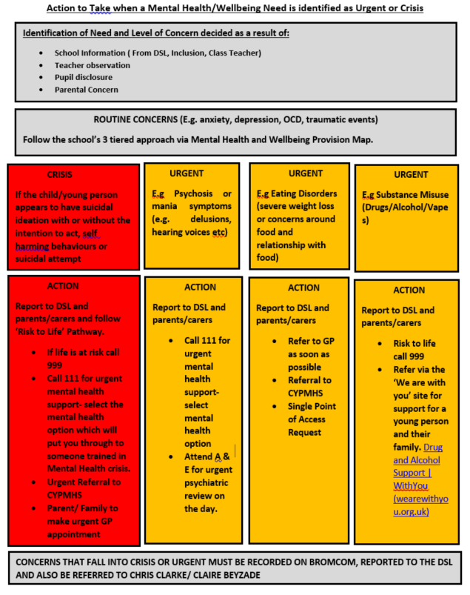
Appendix D- Action needed during ‘urgent’ or ‘crisis’ events.

Appendix E: Guidance for referring to CYPMHS (Kent and Medway)

Overview
The Children and Young People’s Mental Health Service (CYPMHS) offers NHS-provided mental health assessments, interventions, and evidence-based treatments for individuals aged 0–18 in Kent and 0–19 in Medway. The service addresses a range of mental health difficulties, including low mood, depression, severe anxiety, self-harm, eating disorders, conduct and behavioural issues, tics and Tourette’s, suicidal thoughts, ADHD, and autism spectrum conditions.

Referral Pathways

1. Emotional Wellbeing and Mental Health Referrals
- Who Can Refer: Referrals can be made by professionals (e.g., GPs, teachers, school nurses) and by self-referral from parents or young people.
- How to Refer: Complete the online referral form available on the NELFT website.
- What Happens Next:
  - Referrals are reviewed daily by the Single Point of Access (SPA) team.
  - Screening occurs within two working days.
  - Referrals are prioritised based on clinical need and risk level.
  - Assessments aim to take place within 12 weeks.
  - Treatment, whether consultant or non-consultant led, aims to commence within 18 weeks.

2. Learning Disabilities, Tics, and Tourette’s Referrals
- Who Can Refer: Referrals can be made by professionals and by self-referral from parents or young people.
- How to Refer: Complete the online referral form available on the NELFT website.

3. Autism and ADHD Assessments
- Who Can Refer: Only professionals (e.g., GPs, educational psychologists, school SENCOs) can make referrals for autism and ADHD assessments.
- Required Documentation:
  - Family Developmental History Form: To be completed by the family.
  - Education Observation Profile: To be completed by the educational setting.
  - ADHD Observation Form: For use by professionals if the child is not in education.
  - Autism Observation Form: For use by professionals if the child is not in education.
- Submission Process:
  - All forms must be completed and ready for upload before starting the online referral form.
  - The online referral form must be completed in one session; it cannot be saved for later.
  - After submission, a confirmation email will be sent. If not received, check the junk folder or contact the SPA team at 0800 011 3474.

Contact Information
- Single Point of Access (SPA) Team: 0800 011 3474
- Email for Autism Assessment Enquiries: AATEnquiries@nelft.nhs.uk
- Local Office Contacts:
  - Medway: 0300 300 1989
  - Maidstone: 0300 300 1990
  - Tonbridge: 0300 300 1992
  - Dartford: 0300 300 1986
  - Ashford: 0300 300 1982
  - Thanet: 0300 300 1983
  - Swale: 0300 300 1991
  - Canterbury: 0300 300 1984
  - South Kent: 0300 300 1988

Crisis Support
- Immediate Danger: Call 999 or visit the nearest Accident & Emergency (A&E) department.
- Mental Health Crisis:
  - Call NHS 111 and select option 2 for mental health support.
  - Text SHOUT to 85258 for 24/7 mental health crisis support.
For more detailed information and to access the referral forms, please visit the NELFT 'How to Refer' page: https://www.nelft.nhs.uk/how-to-refer

Appendix F: Individual Care Plan/Pastoral Support Plan Template

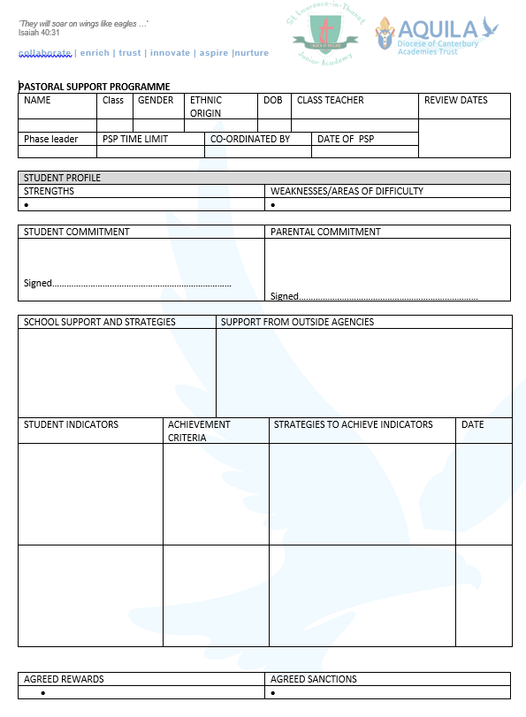
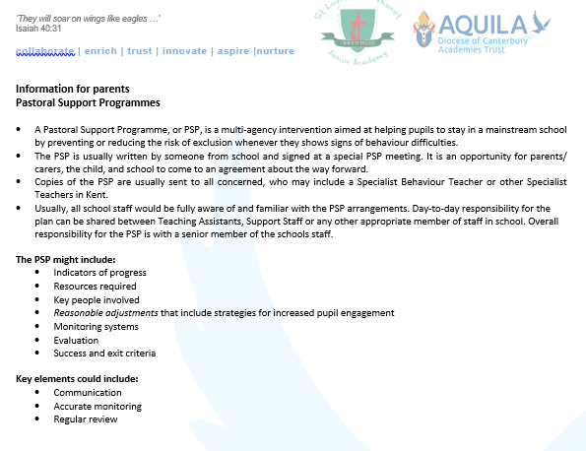

World Health Organisation. Mental health: strengthening our response. 2018. Available from: https://www.who.int/news-room/fact-sheets/detail/mental-health-strengthening-our-response
NHS Digital. Mental Health of Children and Young People in England, 2020: Wave 1 follow up to the 2017 survey. 2020. Available at: https://digital.nhs.uk/data-and-information/publications/statistical/mental-health-of-children-and-young-people-in-england/2020-wave-1-follow-up
McManus S, Bebbington P, Jenkins R, Brugha T. (eds.) Mental health and wellbeing in England: Adult psychiatric morbidity survey 2014. (2016) Available from: https://digital.nhs.uk/data-and-information/publications/statistical/adult-psychiatric-morbidity-survey/adult-psychiatric-morbidity-survey-survey-of-mental-health-and-wellbeing-england-2014
Kwong A, Pearson R, Adams M, et al. Mental health before and during the COVID-19 pandemic in two longitudinal UK population cohorts. British Journal of Psychiatry. 2020. 218(6).

